Good Luck and Other Charming Symbols
Meanings and some of the origins in the order of the corresponding
Alphabet letter or number. Lower case a-z, 0-9
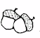Acorns…GOOD LUCK. Norse tradition
the Norse believed that acorns displayed on a
windowsill would protect a house from lightening.
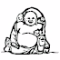Laughing Buddha….Luck and Happiness. Japan & China
He brings happiness to others through his appearance
and rubbing his belly is supposed to bring luck
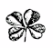4 leaf clover…….GOOD LUCK….Celtic Tradition

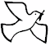Dove………Peace
http://www.widdershins.org/vol8iss6/05.htm

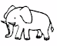elephant……..Luck and Longevity…India and China

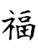Fu………Good Luck----Chinese

LadyBug…….Good Luck…various world cultures

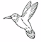HummingBird….Joy
It reminds us to find joy in what we do and to sing it out.

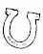 horseshoe………..GOOD LUCK…USA & Europe
The origin is believed to be tied to the proscribed magical powers of iron

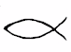 Ichsthy Fish….Christianity
The fish's first known use as a Christian religious symbol
was sometime within the first three centuries AD.
http://www.eureka4you.com/fish/fishsymbol.htm

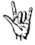I love You……..sign language
In American Sign Language, a simple gesture speaks volumes.
The letters I, L, and Y made together mean "I love you

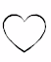Heart……….Love
http://www.heartsmith.com/heartHistory.html
and The heart has always been the most popular symbol of true love.

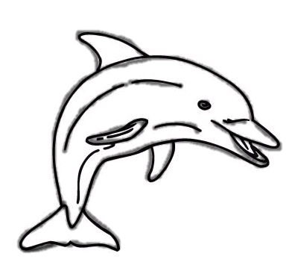Dolphin….Luck Many people in the Eastern Mediterranean
countries believe the dolphin is lucky.

 Musical Note……..Harmony

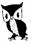Owl…….Wisdom
The Owl has been the symbol of Wisdom in many cultures for many generations.

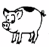Pig……Good Luck ….Germany

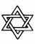Star of David….Good luck
The symbol of intertwined equilateral triangles is a common
one in the Middle East and North Africa, and is thought to bring good luck
http://www.us-israel.org/jsource/Judaism/star.html

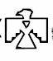Thunderbird…..
the symbol of the sacred bearer of happiness unlimited, the thunderbird.

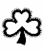Shamrock….Good Luck and Trinity

Sea Turtle….Longevity
a symbol of good luck and prosperity

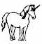Unicorn….Purity & Truth
In the Middle Ages, the unicorn became a symbol of purity
Unicorns also were a symbol of truth

 Sword….The Sword: A symbol of justice, insight, wisdom and truth, swords are believed to hold supernatural powers.
Examples of the magic of the sword are seen with Excalibur (the sword of King Arthur),
the sword of the Archangel Michael and the symbols of alchemy.
The sword also forms the shape of the cross.

Wishbone……Good Luck
attract good luck and to make wishes and dreams come true.

Flamingo……Good Luck & Happiness
. The Flamingo tells us that after the sorrow comes happiness.

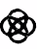Celtic Eternity Rose….Eternity

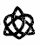Celtic Lovc Knot….. Love

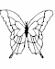Butterlfy…. Good luck & Rebirth

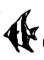Angel Fish…….Beauty & Grace

Infinity

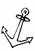Anchor…..Hope & Protection
A symbol of hope, because it is an aid to mariners in danger of shipwreck.

Sea Horse….Magic
From practitioners of ancient Chinese medicine to tourists in Florida,
we've believed their magic gave us wondrous things
http://www.sheddnet.org/ani_bios_22.html

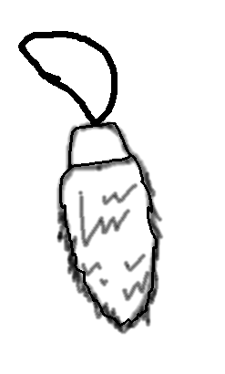Rabbits foot……….Good Luck
hind foot of a rabbit used as a talisman has been a good luck charm for the common man for ages

Pot of Gold
Radiance and warmth.
http://www.the-tree.org.uk/Sacred%20Grove/MysteryTour/potofgold.htm

Ankh…..Life…Ancient Egyptian Hierglyphics
the ankh brings good health,
promotes fertility, and strengthens the psychic powers.

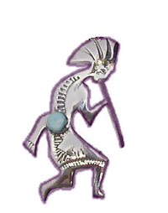 Kokopelli………..Good Luck….Native American
It is believed that his good luck powers
came from his power to create life.

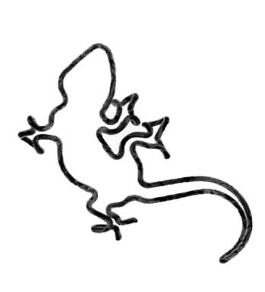Gecko ………………Good Luck
geckos (Gekko gecko) are regarded as harbingers of luck,
good fortune, and fertility in parts of southeast Asia

This is meant to be a fun font!! Share some good luck with your friends in your emails….or in your word documents.

The more I researched on the GOOD LUCK CHARMS….the more varied the descriptions became.
Here are several of the sites I obtained info from.

Other sources of information >>> http://www.luckfactory.com/index.html
http://www.marcsky.com/goodluck.html
http://www.journey-to-self.com/Symbol%20Glossary.htm

