Keto fit

The Advanced Weight Loss Formula- [Keto Fit](https://thewellnesscare.com/keto-fit/)

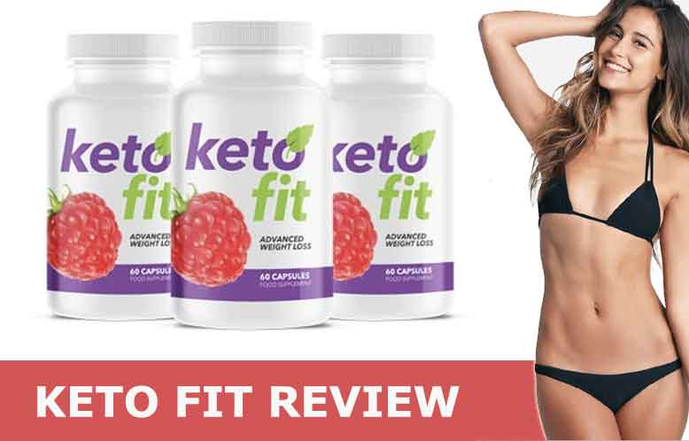

Keto fit is the very fast fat burning solution for those people who ware not satisfied by trying other fat reducer product because of its containing the weight loss supplement. Keto fit is the best health supplement and fast fat reducer due to its containing purely natural herbs and ingredients, in which BHB is most powerful ingredients which play the most significant role in reducing extra calories. This is BHB is also called Beta-hydroxybutyrate which increased body in ketosis level where a large number of activities are processing during the fat burning process. It helps to reduce your body extra fat fastly and helps transformed this burned fat into energy. Keto fit product such a revolutionary transformation of body fat into energy and make our body toned and fit. Keto fit is the best supplement in today because of its super fast [fat oxidation](https://thewellnesscare.com/keto-fit/). Keto fit is a weight loss supplement is also available in the market at a very affordable price. if you want to reduce extra fat and become healthy and fit, Try Keto fit today through our website <https://thewellnesscare.com/keto-fit/>

In most of the traditional diet, it only burns your carbohydrate and gives your body energy, but Keto fit diet supplements are given us result to burning fat of your body and transformed it into energy. Keto fit diet supplements stimulate your bodies BHB level, where your body get ketosis state and body fat get burned so fast as you didn't imagine. It never helps to reduce your body extra fat but also helps to regulate our other hormone functions. Due to some Ketones element like BHB helps your body get fast fat burning. Try this Keto fit diet at an affordable price!

<https://thewellnesscare.com/keto-fit/>

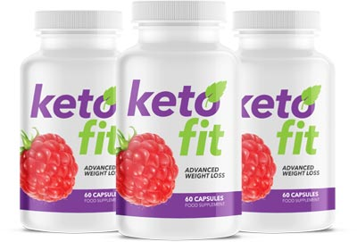

Hello, friends, my name is Vline Coulee from the United States. I am a health expert love you write a review over weight loss supplements if you are seeking for proven pills which really works on bad fat or belly fat area then you can buy Keto Fit pills made with natural ingredients. Keto fit pills have the power to burn your fat fast without any side-effects. For good results, you need to you use these keto fit pills continue for the next 5-6 months. For more details about kept fill tablets read on https://thewellnesscare.com/ or visit specific page: <https://thewellnesscare.com/keto-fit/>.



[Keto fit](https://thewellnesscare.com/keto-fit/) takes place in human life very important and it is better other than the more fat reducer products available in the market. Its results amazing and revolutionary due to its instant fat oxidation procedure. In Keto fit have the ability to lose extra body fat besides it containing all natural and hygienic herbs, BHB ingredients and Ketone formula. It gives better to the fatty body by processing of fat burn transform into energy. Try Keto Fit today for better fitness and lifestyle. <https://thewellnesscare.com/keto-fit/>

See our social links too:

<https://mix.com/ketofitreviews>

<http://anyflip.com/homepage/jibo>

<https://letterboxd.com/patriciacarter/>

<https://issuu.com/keto_fit>

<https://ketofitreviewscanada.hatenablog.com/>

<https://thewellnesscare.com/>

<https://www.weibo.com/6882240985/profile?is_all=1>

<http://000000book.com/users/breakthroughbelly>

<https://mysp.ac/3jJUx>